DESIGN THINKING LAB REPORT- 2

Topic:

Electricity outage information is not communicated clearly.
Name: Alfred Antony
Roll No: 24BTCE225

STEP 1: Define the Target User
Target Users:
- Age: 18–60 years
- Education: School / College / Working professionals
- Device: Smartphone
- Digital Literacy: Medium
- Services Used: Electricity board app, SMS alerts, WhatsApp groups, websites
Problem Context:
Users do not receive clear, timely, and understandable information about power cuts.

STEP 2: Initial Assumptions
ID | Assumption
A1 | Users do not get outage alerts on time
A2 | Messages are confusing or incomplete
A3 | Users check multiple sources for confirmation
A4 | Apps/websites are difficult to navigate
A5 | Users want exact restoration time

STEP 3: Interview Questions
- How do you usually know about a power cut?
Mostly through neighbors, sudden power loss, or checking social media/WhatsApp groups.
- Do you receive any SMS or app notification?
Rarely. Notifications are either delayed or not received at all.
- What problems do you face during electricity outages?
Work disruption, device charging issues, internet loss, and difficulty planning daily activities.
- Is the restoration time clearly informed?
No. Restoration time is usually unclear or keeps changing.
- Which method do you prefer for outage updates?
Real-time SMS or mobile app notifications from the official electricity provider.
- What improvement would you like in outage communication?
Advance alerts, accurate restoration time, and one reliable official communication platform.

STEP 4: User Interview (Sample)
Observations:
- User repeatedly checks phone for updates
- Shows frustration due to uncertainty
- Searches Google or asks neighbors
User Statements (Quotes):
- “I never know how long the power cut will last.”
- “SMS comes late or not at all.”
- “Website is confusing to check.”

STEP 5: Empathy Map

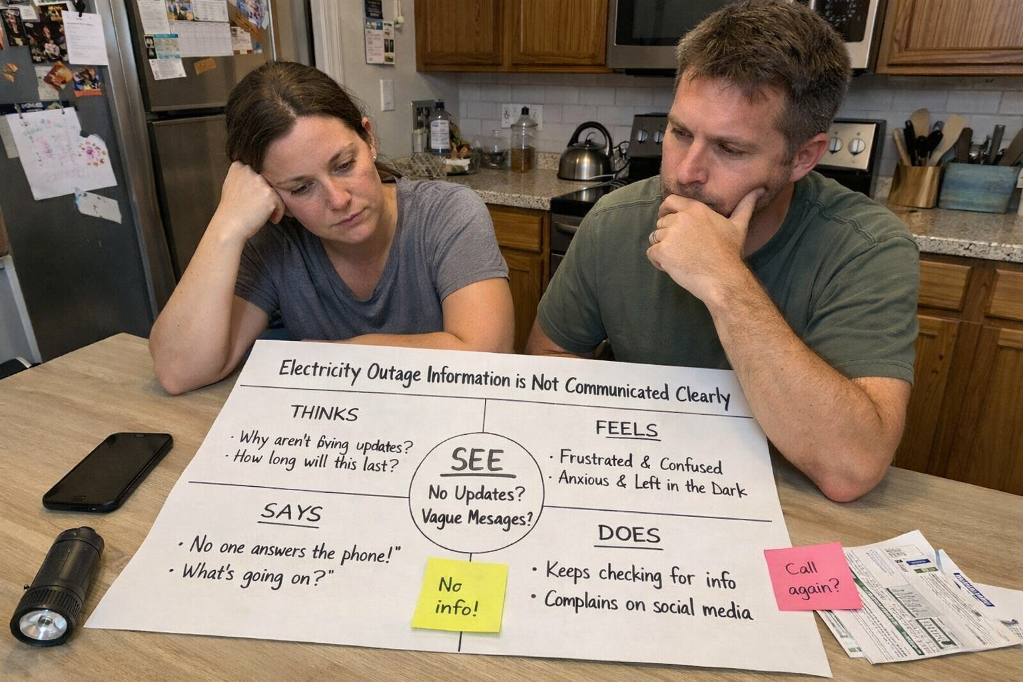

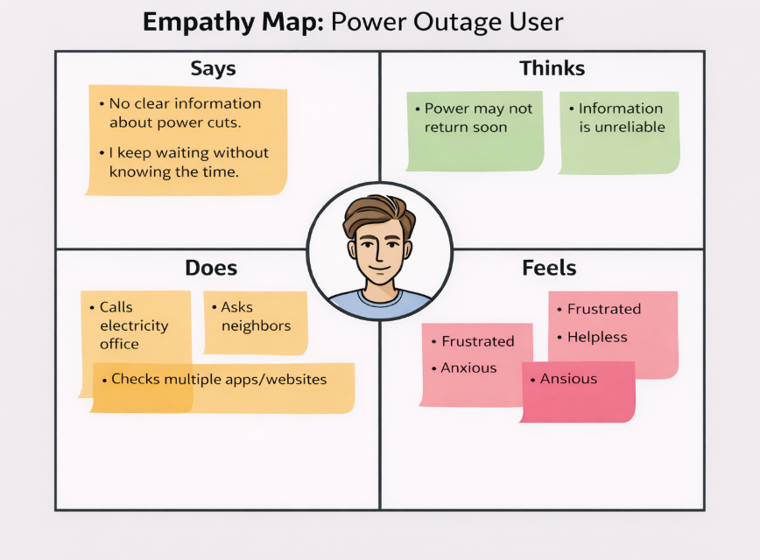

STEP 6: Validate Assumptions
Assumption | Validated? | Reason
Alerts not received on time | ✅ | User reported delay
Messages are confusing | ✅ | User couldn’t understand info
Checks multiple sources | ✅ | Observed behavior
App difficult to use | ⚠️ | Mixed response
Needs exact restoration time | ✅ | Strong user need

STEP 7: User Insights
- Users need clear and timely outage communication.
- Uncertainty of restoration time causes frustration.
- Trustworthy single source of information is important.
❌ Users don’t care about outage details
✅ Users want accurate time and clear updates

STEP 8: User Persona

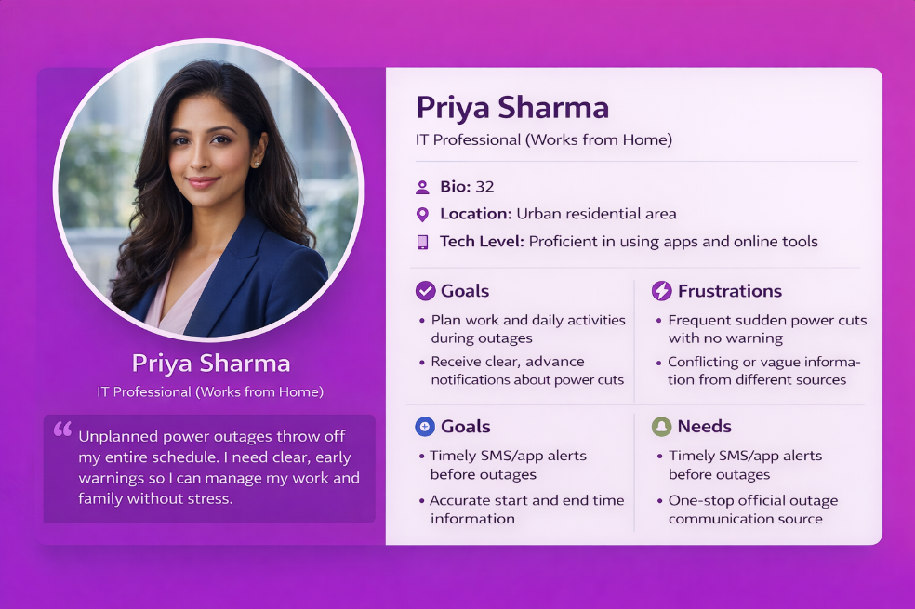

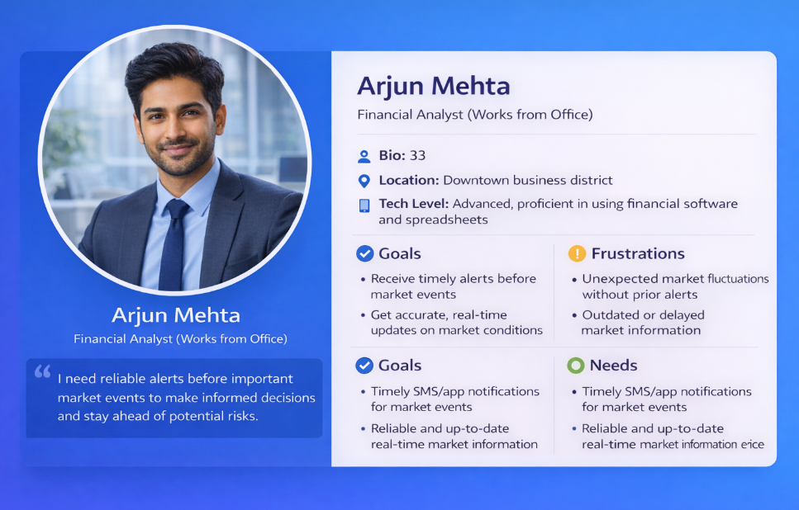

STEP 9: Translate Insights to Software Needs
Insight | Software Requirement
Need clear alerts | Instant push notification & SMS
Wants restoration time | Show exact estimated time
Confusion in website | Simple, clean interface
Needs single reliable source | Centralized outage dashboard
Frequent checking | Live status updates
STEP 10: Reflection
1. What surprised you?
Users feel more stress from uncertainty than the outage itself.
2. Which assumption was wrong?
Not all users find apps difficult; the issue is mainly unclear information.
3. How did empathy change thinking?
Focus shifted from technical outage to user communication clarity.
4. Effect on software design?
Design must prioritize:
- Clear language
- Real-time updates
- Accurate restoration time

